# MANAV RACHNA UNIVERSITY

Department of CST

(Software Engineering Lab– CSH207B-P)

## (Lab 0)

**Learning Outcomes:** Students will be able to understand how to design the database of a software system.

1. Write problem statement for library Management system.
2. Write problem statement for result Management system.

### 1.Problem Statement for Library Management System:

A software is to be developed for automating a college library. The system should be user friendly and easy to use.

1. Issue and return of books:
2. A member should be able to issue books.
3. Each member can issue a maximum of 5 books.
4. Course books can be issued for a semester and general books can be issued for 15 days.
5. The software takes the current system date as the date of issue and calculates the date of return.
6. The book can be returned within the given time period.
7. Student can renew book return date within the existing time period of return date.
8. Members should be able to reserve books that are not currently available.
9. Searching of books:
10. By book title.
11. By author name.
12. By subject name.
13. By publication.
14. Updating data:
15. Addition of new books.
16. Removal of books.
17. Edit book info.
18. Registration of new account-for students and faculty.
19. Issuing of library card.(Only librarian)
20. Removal of accounts.(Only librarian)
21. Updation of account: Librarian can update all the accounts, students and faculty can onlu ypdate their personal account.
22. Fine:
23. Late fine is levied on student or faculty if book is returned after due date.
24. If a member loses the book, fine is imposed.

### 2.Problem Statement for Result Management System:

A software is to be developed for result management system. The system should be user friendly and easy to use.

1. Upload/Update data:

* Data entry operator and teachers will have right to upload or update student result data.
* Data entry operator will be responsible to maintain student record and information.
* Data entry operator will also be responsible to maintain semester and subjects data.
* Faculty can update/upload/edit the result.
* Admin can also update result.

1. View Data:

* Students can view their result.(Pass/Fail)
* Students can view their marks.

1. Account management:

* Admin can create user account.
* Admin can modify/edit user account.
* Admin can delete user account.
* Admin can generate results.
* Admin can reset system.
* Admin can give and withdraw access from users.

## (Lab 0)

1. A university wishes to develop a software system for library management activities. Design the problem statement for the software company.

A software is to be developed for automating a college library. The system should be user friendly and easy to use. It will need to take records of students, faculties and employees’ info at the university into account. The data can be extracted from the college administrative cell. The software system should be able to generate unique id for the readers. It should be able to perform calculations regarding fine amount. The fine amount can later be extracted by the accounts department of the university.

1. Identify the requirements of the project from the Problem statement.
   * Issue and return of books
     + A member should be able to issue books.
     + Each member can issue a maximum of 5 books.
     + Course books can be issued for a semester and general books can be issued for 15 days.
     + The software takes the current system date as the date of issue and calculates the date of return.
     + The book can be returned within the given time period.
     + Student can renew book return date within the existing time period of return date.
     + Members should be able to reserve books that are not currently available.
   * Searching of books
     + By book title.
     + By author name.
     + By subject name.
     + By publication.
   * Updating records of books
     + Addition of new books.
     + Removal of books.
     + Edit book info.
     + Registration of new account-for students and faculty.
     + Issuing of library card (Only librarian).
     + Removal of accounts (Only librarian).
     + Updating of account: Librarian can update all the accounts, students and faculty can only date their personal account.
   * Fine
     + Late fine is levied on student or faculty if book is returned after due date.
     + If a member loses the book, fine is imposed.

## (Lab 1)

1. A college wishes to develop a software system for result management activities. Design the problem statement for the college.

The current result management system used by exam cell is slow and requests a lot of manpower and paperwork. Also, the process is slow and inaccurate. It also has insufficient storage space and handling the data requires staff which leads to the increase in cost.

1. Identify the requirements of the project from the Problem statement.

Automated result management system requirements are:

* 1. It leads to less human error as well as calculation mistake because it is calculated by the software.
  2. The automated software is more secure because it has double level authentication.
  3. Retrieving and adding data is highly efficient if the software is automated.
  4. Huge storage space to store the data into database.
  5. Less staff will be required to manage the software.

1. A company wishes to develop a software system for payroll management activities. Design the problem statement for the company.

The current payroll management system is done manually by the staff manager. This method is ineffective and time consuming. Security of data will be less and productivity is also less because keeping track of leaves is a tedious task. The physical method contains too much paperwork and this leads to delay in paying salary to the employees.

1. Identify the requirements of the project from the Problem statement.

The requirements of automated payroll system are:

* 1. Employee apply for leave through software which will handle leaves and data of overtime effectively.
  2. Data will be secured in the database and protected through a password.
  3. There is no need of employee to handle their leave records. It is efficiently handled by software.
  4. At the end of each month, pay-slip will be generated automatically and forwarded to the employee through mail and their salary will be transferred in their bank accounts.

1. A factory wishes to develop a software system for inventory management activities. Design the problem statement for the factory.

The current inventory management system is handled manually. The tracking is inconsistent and there is no reminder for the various delivery. Due to this, working in warehouse is inefficient. All the documentation is done manually which is not a secure way.

1. Identify the requirements of the project from the Problem statement.

Requirements of automated Inventory Management System are:

* 1. In automated system there is a consistent tracking of delivery over maps.
  2. Continuous reminder of delivery is provided by the software.
  3. Continuous tracking of temperatures of warehouse and item stocks in warehouse.
  4. Data is secured in database as they are password protected.

(Lab 2)

**Learning Outcomes:** Students will be able to understand how to design the database of a software system.

* 1. Draw the E-R diagram for library Management system. 2.Draw the E-R diagram for Result Management System.

### ER Diagram for Library Management System:

### ER Diagram for Result Management System:

## (Lab 3)

* Draw the E-R diagram for Payroll System.

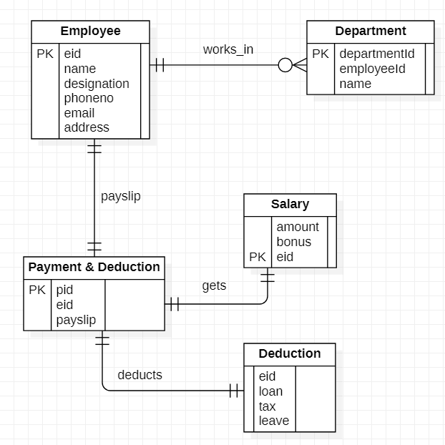

* Draw the E-R diagram for Inventory Management System.

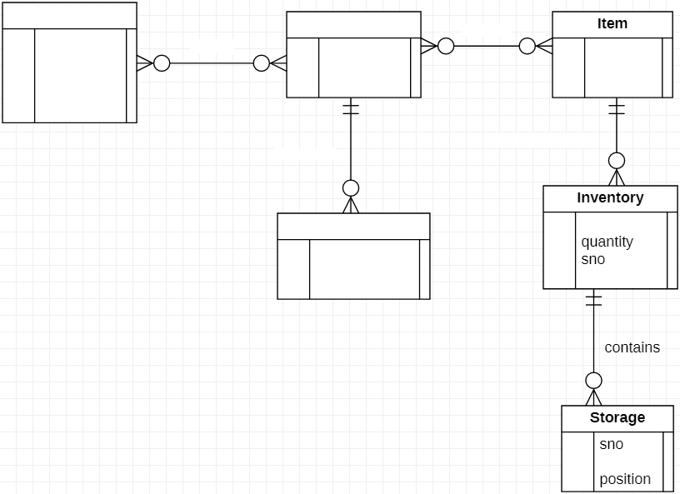

Customer

name phoneno address emal

PK custonierld

Order

PK orclerNo

itenilcl custanierld

request

places

PK iteniNa

iteniDesc barCacle

provide details

deliverecl

Shipments

PK shipment No shipnientDate orclerNo

itenilcl

PK inventaryld

PK

name